15’ Sea Spray Catamaran

$800 O.B.O.
- Mast floatation included - not shown in photo
- Sealed buoyancy added in hulls and mast

- Trampoline replaced 2 years ago
- Sails in excellent condition
- Custom trailer included

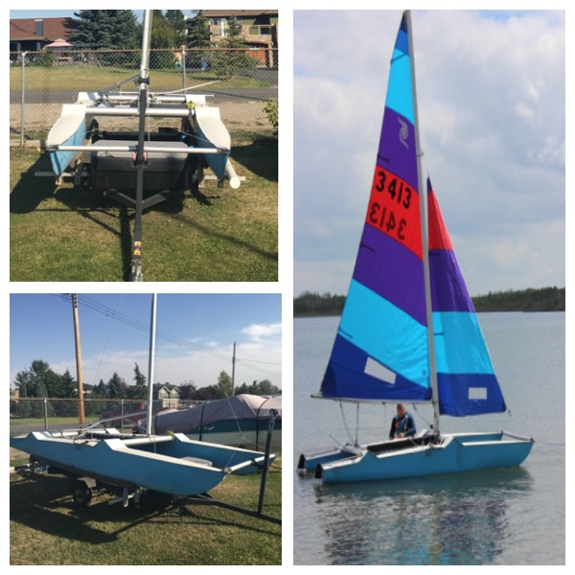

Contact Alasdair:
403-837-9290
arobertsonmore@me.com

