Calgary Yacht Club
2019 CYC Brass Monkey Sailing Instructions
12 October , 2019

1. RULES
1.1 The regatta will be governed by the ‘rules’ as defined in The Racing Rules of Sailing.
2. NOTICES TO COMPETITORS
2.1 Notices to competitors will be posted on the official notice board located on the exterior west side of the change room building.
3. CHANGES TO SAILING INSTRUCTIONS
3.1 Any changes to the sailing instructions will be posted 15 minutes prior to the Competitors Meeting.
4. SCHEDULE OF RACES
4.1 A Competitors Meeting will be held at 12:00
4.2 The scheduled time for the warning signal for the first fleet is 13:00
4.3 The scheduled time for the warning signal for subsequent fleets is 13:03
4.4 A fleet shall comprise 5 or more boats
5. THE COURSES
5.1 The course will be displayed on the Signal Boat before the first preparation signal of a race.
5.2 The “A” course will consist of windward/leeward sausage(s) with a finish line outside the course on the starboard side of the Signal Boat.
5.3 The “B” course will consist of windward/leeward sausage(s) with the start/finish line in the inside of the course. The start/finish line will be considered an obstruction, unless starting or finishing, if the signal boat is anchored and flying an RC flag.
5.4 The course to be sailed will be displayed on the Signal Boat with either an “A” or “B” followed by one or two sausage symbols, with each symbol representing once around the sausage.

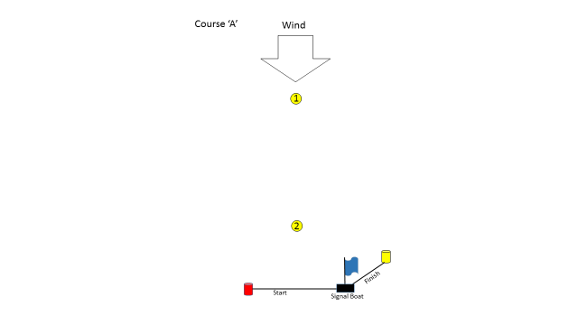
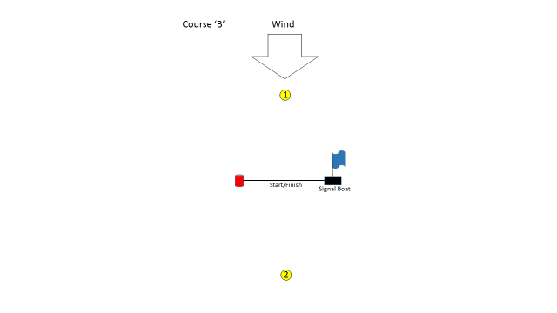

6. MARKS
6.1 Marks of the course will be spherical yellow marks (‘exercise balls’).
6.2 The start mark will be the orange pin in the vicinity of the Signal Boat.
6.3 The finish mark will be the yellow spar in the vicinity of the Signal Boat when the “A” course is sailed.
6.4 The finish mark will be the orange pin in the vicinity of the Signal Boat when the “B” course is sailed (finish mark same as start mark).
7. THE START
7.1 The races will be started by using rule 26 but the warning signal shall be made 3 minutes before the starting signal, the preparatory signal shall be made 2 minutes before the starting signal.
7.2 The start line shall be between the orange flag on the Signal Boat and the start mark (orange pin) at the port end of the starting line.
7.2 2 As determined at the sole discretion of the Race Officer the start line shall be shortened as an aide to increase concentration during the start sequence
8. SHORTENED COURSE
8.1 The course may be shortened at any mark.
9. TIME LIMITS
9.1 If no boat has passed Mark 1 within 20 minutes the race will be abandoned.
9.2 When it is in the best interest of the fleet and its competitors, the race committee may award finishing places to boats which are delaying the finish of the race (on course finish). The scoring abbreviation for an on course finish will be OCF.
10. THE FINISH
10.1 The finish line shall be between the yellow flag on the Signal Boat and the finish mark.
11. PROTESTS AND REQUESTS FOR REDRESS
11.1 Protests shall be delivered to the club office within the protest time limit.
11.2 The protest time shall commence when the Signal Boat docks on shore and will last 15 minutes.
12. SCORING
12.1 One race is required to be completed to constitute a series.
12.2 When fewer than 5 races have been completed, a boat’s series score will be the total of her race scores.
12.3 When 5 or more races have been completed, a boat’s series score will be the total of her race scores excluding her worst score.
13. SAFETY REGULATIONS
13.1 All competitors are required to wear a PFD at all times while on the water. Competitors may temporarily remove their PFD only while adjusting clothing or personal equipment. This changes Rule 40.
13.2 Competitors who require assistance should wave one arm with hand open. If no assistance is required, the arm should be displayed with fist closed.
13.3 A boat that retires from a race shall notify the race committee as soon as possible.
14. DISCLAIMER OF LIABILITY
14.1 Competitors participate in the regatta entirely at their own risk. See Rule 4 Decision to Race. The organizing authority, its agents and the Calgary Yacht Club will not accept any liability for material damage or personal injury or death sustained in conjunction with or prior to, during or after the regatta.

