Dinghy Sailboat Trailer

Custom built steel and aluminium dinghy trailer in excellent condition.
Fits three lasers, three dinghys and other boats.
Everything you need to go to a regatta with.

- EZ Load Trailer
- Drop Leg
- Aluminum triangle boat rack padded for up to three dinghys
- Ski box storage container
- Spare tire

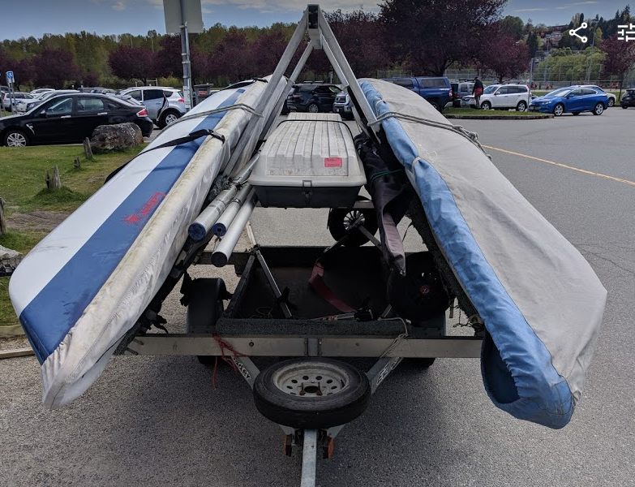
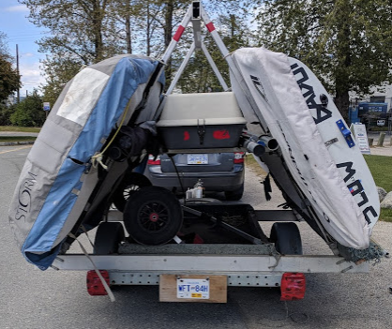
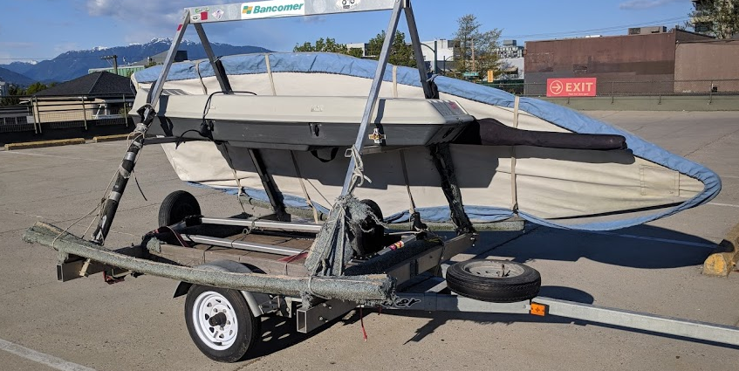
$1,250

For more information contact
thom.stubbs@gmail.com
403-220-1144

