LASERS FOR SALE

-2 Laser Sailboats (built 1981 and 1974) complete with sails, spars and all riggings
-1 Trailer (will carry 3 boats and all riggings)
-Complete Radial rigging (sail, boom and bottom section)
Extras:
-2 extra topsections
-extra tiller
-extra ropes and hardware and more

Contact: Joan Metzger
403-358-1473 (Red Deer)
danjoan@telusplanet.net
Price: $4,500
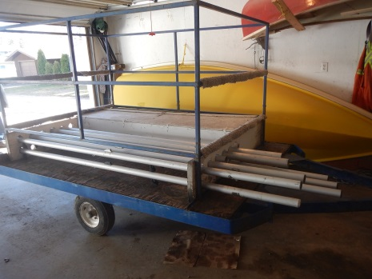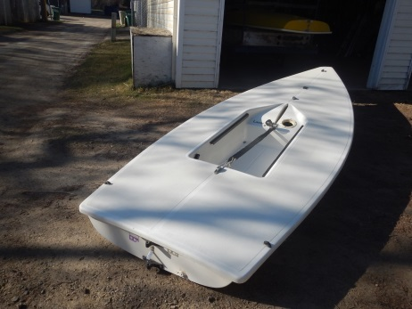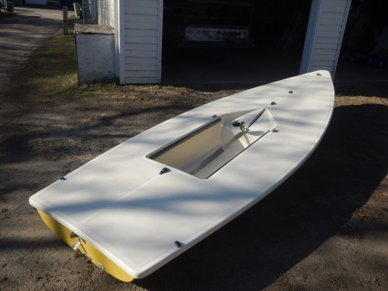
3 boat trailer 1981 1974

