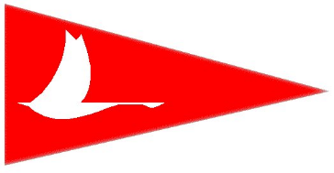Calgary Yacht Club
Letter of Informed Consent
Participant’s Name: ____________________________________________________________
Activity: ______________________________________________________________________
Date of Activity: _______________________________________________________________
While every reasonable precaution is taken for your safety and good health, some sports and activities carry with them the inherent risk of personal injury beyond the risks associated with many recreational activities at the Calgary Yacht Club. I understand and accept these risks and agree that by participating, I will be taking part in a recreational activity that presents the potential for personal injury.
Information received is confidential and is being gathered for the purpose of serving you while in the participating in the activity listed above at Calgary Yacht Club. Any medical information collected here serves to authorize the Calgary Yacht Club and its Staff and Volunteers, to obtain medical assistance in emergencies.
Participant’s Name __________________________________ DOB _____________________
Address ______________________________________________________________________
Cell # ________________________________ Alternate # _____________________________
Allergies _____________________________________________________________________
Emergency Contact Info: _______________________________________________________

Do you have any physical concerns or limitations that staff should be aware of? □ yes □ no
If yes, please explain:
______________________________________________________________________________
______________________________________________________________________________

Your safety is our primary concern. All precautions will be taken for your well-being and protection. (please turn over)
I, _________________________authorize any Calgary Yacht Club Program Personnel to sign a consent for medical treatment and to authorize any physician or hospital to provide medical assessment, treatment or procedures.
I, _________________________undertake and agree to indemnify and hold harmless Program Personnel, the Calgary Yacht Club and its leaders from any loss, damage or injury suffered as a result of being part of the activities of the Calgary Yacht Club, as well as of any medical treatment authorized by the supervising individuals representing the Calgary Yacht Club.
Photos

Please sign below to grant permission for the reasonable use of your picture in brochures and promotional material, on our website and social media channels and in our newsletters.

Participant
I have read, understood and agree with the above.
Participant Signature __________________________________________________________
Printed Name _________________________________ Date ___________________________
Witness Signature _____________________________________________________________
Printed Name _________________________________ Date ___________________________

