On Sale at Reduced Price: Lightning 19' Sailboat with Trailer
Only $2,000

This beautiful sailboat can be used for racing or as a day sailer.
The boat comes with:
- Trailer
- Wood deck
- 2 Sets of Main and Jib (one almost brand new)
- Spinnaker
- New Jib Sheets
- Lots of extras: Cover, Vests, Bailing pump, Ores, Fenders, Boat Hook

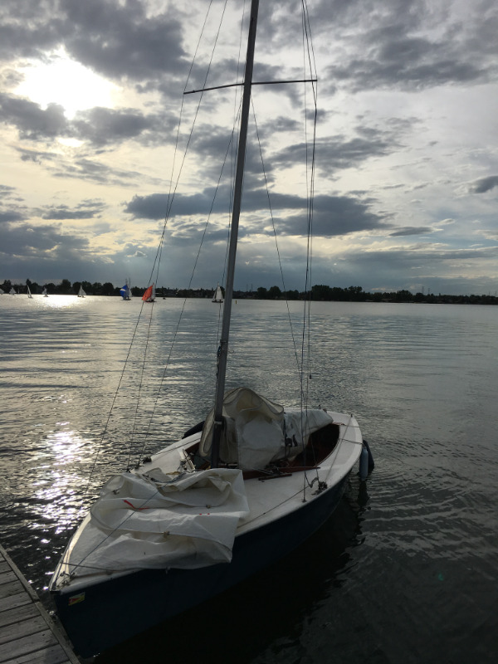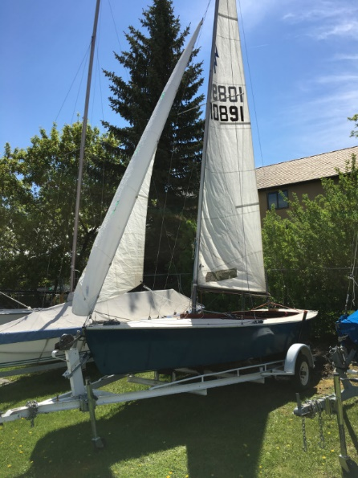
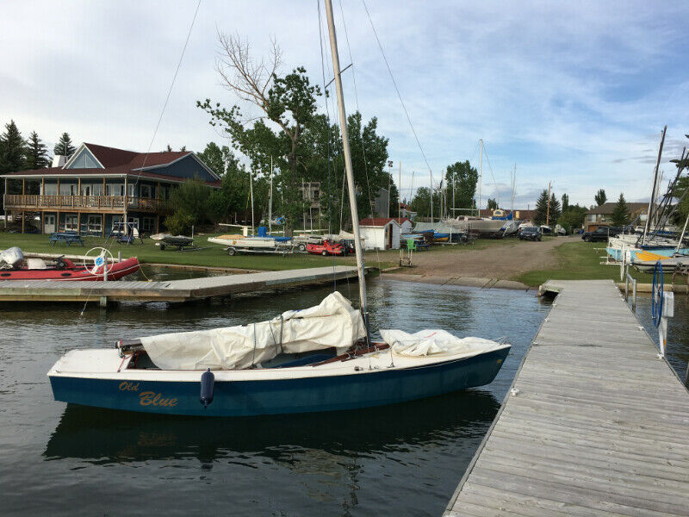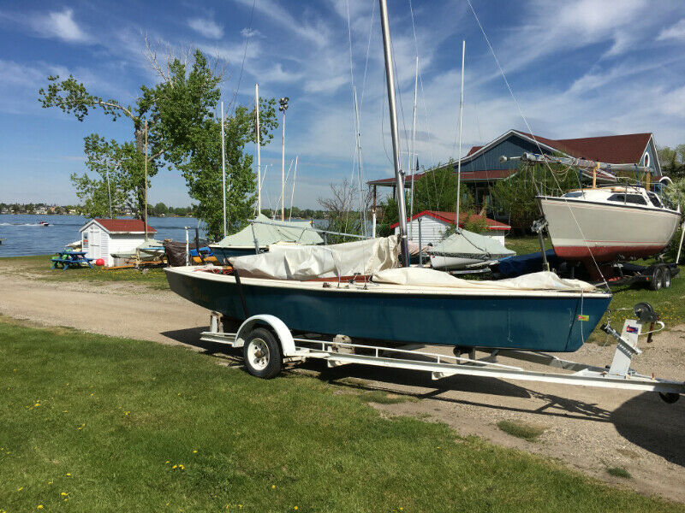

Info @: (403) 389 9455 – wmelillo@shaw.ca

