ENGINEERING FOR KIDS Summer CAMP
(AGES 4 – 7)

Junior Robotics (9:00 am – 12:00 pm)
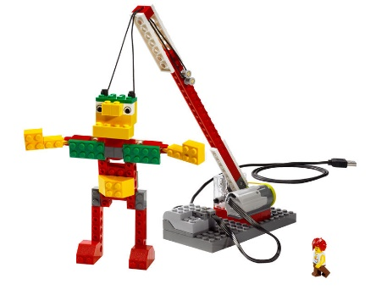
Let the young engineers loose as they build the coolest Lego® Amusement Park!
Kids will explore the basic concepts of simple machines and how we use them to achieve even our most grandiose goals! Students will use LEGO® WeDo construction and resource kits to produce new and exciting builds that will be used to create Kelvin’s Amusement Park.

Junior Inventors (1:00 – 4:00 pm)
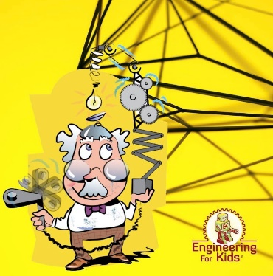
A week of fun, creativity, and of course -- engineering!
Over the course of a week, students will invent new machines and explore creative design solutions using the Engineering Design Process. Discover how a wind-up toy works and design your own drawing robot inside the Engineering For Kids Inventor’s Workshop.

$185 for Half Day / $325 for Full Day
July 31 – Aug 4 @ Calgary Yacht Club Chestermere
587-349-4555
ENGINEERINGFORKS.com/Calgary

